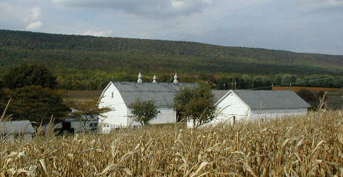
Farmland Preservation News
Lehigh County
OSWALD FARM. LYNN TOWNSHIP
Spring 2024

Selling Your Farm?
Buying a Preserved Farm?
The Farmland Preservation Program has been in existence since 1988, and many preserved farms have changed ownership.

REMEMBER: Every time there is a change of ownership of a preserved farm, State law requires that a new property deed MUST be recorded and include the original Deed of Easement as an attachment. Please contact our office before you go to settlement and we would be happy to review your deeds to be sure that they are correct.

We can answer any questions that you or your attorney may have and we have samples of properly prepared deeds. Don’t hesitate to contact us, we are happy to help with this process.

Contact us if you have questions about subdivision, building the permitted additional residence or permanent agricultural structures. We have applications for you to complete and we need to approve of these changes.
Of course you also need to communicate with your municipality regarding zoning and with the county assessment office regarding Act 319 and 515 tax implications.

Informative handbooks are available for landowners, municipal officials, attorneys and realtors.

SAVE THE DATE

Hello owners of preserved farms in Lehigh County!

On June 18, 2024 we are celebrating two milestones, preserving over 400 farms and over 28,000 acres in Lehigh County!

The event will be held on the very first farm that we preserved back in 1991, the Graber farm in Lower Milford Township. The farm is now owned by the Barringer family. They rent their land to a local farmer and the farmhouse is headquarters for Logan’s Heroes, a pet/farm animal rescue organization. The Barringers have graciously offered to host our preservation event. Join us for presentations, music, local food and refreshments.

Date : June 18, 2024
Time : 11:00 AM – 1:00 PM
Place : 9411 Kings Highway South
East Greenville, PA 18041

IMPORTANT : Please RSVP to Diane by May 8th if you wish to attend.

Jeff Zehr and Beverly Weaver Retire

FYI, our original Farmland Preservation Director Jeff Zehr has retired and moved to Australia with his wife. Long time staff member Beverly Weaver has also retired and is enjoying her time hiking, and visiting friends and family. We appreciate all of their hard work and dedication over the years.
Funding Update
Inspection Time Again
It’s that time of year again for inspections of preserved farms. As you know, preserved farms need to be inspected every other year, so if you were not contacted last year, or you have a newly preserved farm, your farm is on the schedule for 2024.
Look for a letter with the date of the visit. Staff members do not need to meet with you, nor do you need to be home when they come. Due to COVID19 and Avian Flu concerns personal contact is discouraged. Additional information will be included in the letter.
Looking forward to visiting your farm!

Thank You needs to go out to all the landowners who have applied for preservation. Without your interest and support Lehigh County would not be ranked 4th in PA for the number of farms preserved and 5th for the number of acres for several years now. You understand the need to protect your land and legacy, and our office is working hard to make it easier to do that.
Thank You to all of the Commissioners, past and present, who have supported Farmland Preservation in Lehigh County since 1988. 2024 has another $1 Million dollars in funding from the County, as well as funds from the State and some local municipalities. The productive soils of our area need to be protected and we are well on the way to 28,000 acres preserved in 2024, with the total growing every month.
Some of our Lehigh County Municipal Officials also need a shout out. They have realized the long-term financial savings in preserving farmland in their communities. These communities are: Weisenberg, Heidelberg, Lower Milford, Upper Milford, Lower Macungie, Upper Macungie, Upper Saucon, and North Whitehall.
With over 45 farms on the waiting list right now, funding levels need to remain high in order for this program to continue in its success. Continue to reach out to your county and local elected officials and tell them about the importance of continued funding support for this very important program.
Preserved Farmland by Township
State Approved as of 6/1/24

Township | # of Farms | Acreage
Lynn | 120 | 9085.50
Weisenberg | 59 | 4639.32
Heidelberg | 57 | 3972.86
Lower Milford | 59 | 3931.48
Upper Macungie | 14 | 960.47
Upper Milford | 28 | 1218.04
Lowhill | 10 | 901.91
Lower Macungie | 21 | 1022.29
Washington | 13 | 875.69
Upper Saucon | 13 | 615.04
North Whitehall | 6 | 535.47
South Whitehall | 1 | 70.15
Whitehall | 1 | 154.04
Berks Co. & Etc. | 1 | 19.04
Totals | 403 | 28,028.26

Our Office has Moved
We want to remind everyone that the Lehigh County Agricultural Land Preservation Office moved before COVID. Our new office is located on the ground floor of the Cedar Village Apartment Building, 4234 Dorney Park Road, just down the street from our old office in the Lehigh Ag. Center. The Community Garden personnel have also moved into the “new digs” with us. Parking is located in the top lot and is labeled “Farmland Preservation”.

Contact Information:

Lehigh County Farmland Preservation Office
Cedar Village Apt Building
4234 Dorney Park Road
Allentown, PA 18104
Phone: 610-336-5680 (Listen to recording for extensions)
Diane Matthews-Gehringer, Director of Farmland Preservation
dianematthews-gehringer@lehighcounty.org
Donna Wright, Conservation Program Specialist Municipal Outreach
donnawright@lehighcounty.org

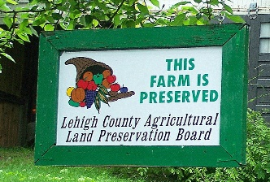
Century Farm? Has your family owned your farm for 100 years or more? Contact us for an application to be recognized by the State and receive a sign from the State for your farm.

