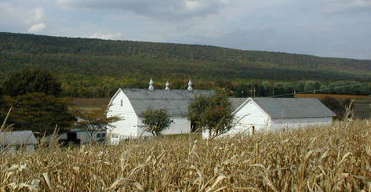
Farmland Preservation News
Lehigh County
OSWALD FARM. LYNN TOWNSHIP
SPRING 2018
Come to the Celebration of Preservation!
June 7, 2018

If you are interested in attending, please contact Donna Wright by June 1st- at the Lehigh County office so we have an accurate count for food and beverages.
610-391-9583 ext 15 or DonnaWright@Lehighcounty.org .
The address for Heidel Hollow Farms is 7419 Saegersville Rd, Germansville, PA 18053.
There will be plenty of parking on site.
Program
State Board Meeting ………….10 am
Presentations by Governor Wolf and other Officials………..Approx. 11:30am
Food and Entertainment to follow

30th Anniversary of Farmland Preservation in PA and Lehigh County!
2018 marks the 30th Anniversary of Pennsylvania and Lehigh County preserving farmland. The Commonwealth will reach an impressive milestone of over 550,000 acres of preserved farmland, the most in the Country. And Lehigh County will have over 23,000 acres preserved, ranking 5th in the State.
To celebrate, on June 7, 2018, Doug Wolfgang, Director, Bureau of Farmland Preservation for the PA Department of Agriculture, Governor Tom Wolf, PA Secretary of Agriculture Russell C. Redding, plus Lehigh County Executive Phil Armstrong, and County Commissioners, along with many other dignitaries, will be attending the June State Preservation Board Meeting at the Fink Farm, Heidel Hollow Farms, LLC. in Heidelberg Township, Lehigh County.
This Celebration of Farmland Preservation is a milestone in both the Commonwealth’s and County’s preservation history. The last time Lehigh County celebrated preserving farmland was in September of 2000 when the County completed 10,000 acres preserved. So much more farmland across the State and County has been preserved since then, and the public’s interest and desire to continue to preserve farmland, if anything, has grown with the latest surveys showing 78% of Lehigh County residents “strongly agreeing with protection of farmland. *”

All preserved farm owners are welcome to attend the celebration with presentations, food, and music starting around 11:30 am.

*Lehigh County Livable Landscapes 2017, LVPC

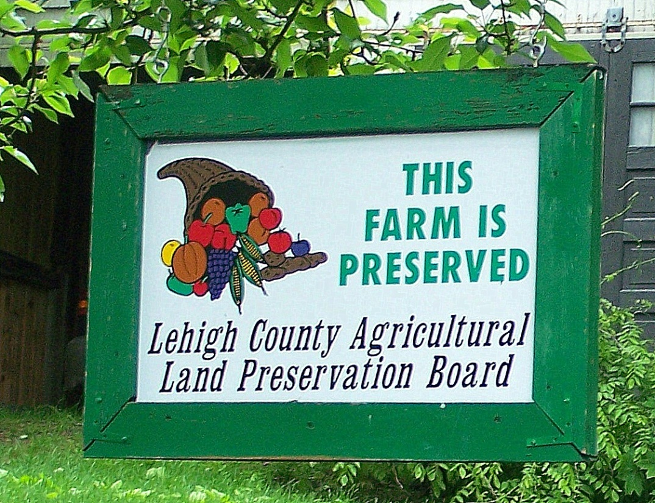
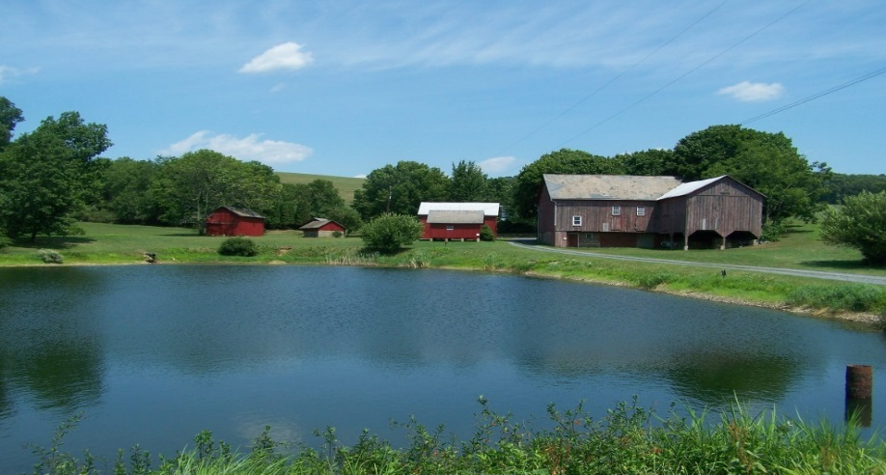
Inspection Time Again
It’s that time of year again for inspections of preserved farms. As you know, preserved farms need to be inspected every other year, so if you were not contacted last year, your farm is on the schedule for 2018.
Look for a letter with the date and approximate time of the visit. Staff members do not need to meet with you, nor do you need to be home when they come. Additional information will be included in the letter.
Looking forward to visiting your farm!

WENTZ FARM, HEIDELBERG TOWNSHIP
Have a Question?
Need Information on the Farmland Preservation Program?
Call our office at 610-391-9583 x 14, OR
Email: Dianematthews-gehringer@lehighcounty.org

Funding Update
In 2016 the Lehigh County Commissioners voted to fund the Farmland Preservation program at a level of $2mil a year for 3 years-2017,2018,2019. Prior to that vote, the Commissioners had committed much less funding per year, but with the increased level, 22 farms were able to be preserved in 2017 alone. In 2018, 24 farms have been selected for preservation, and 2019 looks to be a banner year as well. 50 farms are still on the waiting list and more applications are coming in every week.
Preserved Farmland by Township
As of May 2018

Township | # of Farms | Acreage
Lynn | 95 | 7,842.1
Weisenberg | 49 | 4,192.2
Heidelberg | 45 | 3,460.77
Lower Milford | 46 | 3125.3
Upper Macungie | 11 | 896.33
Upper Milford | 20 | 1010.51
Lowhill | 6 | 562.1
Lower Macungie | 11 | 600.76
Washington | 10 | 732.96
Upper Saucon | 9 | 366.12
North Whitehall | 3 | 383.96
South Whitehall | 1 | 70.2
Other * |  | 132.54
Totals | 306 | 23,376.38
*out of County and additional Twsp land
The Commonwealth commits matching funds based on the level of funding certified by the County, and this helps preserve additional farmland that we would not have been able to. With increased municipal participation, additional funds were certified along with County money for 2018, increasing the amount of preservation even more.
Thank You needs to go out to all the landowners who have applied for preservation. Without your interest and support Lehigh County would not be ranked 4th in PA for the number of farms preserved or 5th for the number of acres. You understand the need to protect your land and legacy, and our office is working hard to make it easier to do that.
Thank You to all the Commissioners, past and present, who have supported Farmland Preservation in Lehigh County since 1988. The amazingly productive soils of our area need to be protected and over 23,300 acres have been so far.
Some of our Lehigh County Municipal Officials also need a shout out. They have realized the long term financial savings in preserving farmland in their communities. Recent studies have shown that open farmland increases home values, decreases the spending on infrastructure, and costs much less in school taxes due to the fact “cows don’t go to school”.
With over 60 farms on the waiting list, funding levels need to remain high in order for this program to continue in it’s success.

