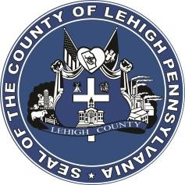

LEHIGH COUNTY

Public Information Office

Government Center

|
17
South
Seventh Street

Allentown, PA

18101
-
2401

Phone:
610
-
782
-
300
2

|
Fax: 610
-
8
71
-
275
5

Press Release

FOR IMMEDIATE RELEASE: CONTACT: Adrianna Calderon May 30th, 2023 610-782-3002

Lehigh County Hosts 5th Community Outreach Day Event

Allentown, PA- On Saturday, June 10th, the Lehigh County’s Public Defenders office will hold its fifth Community Outreach Day event. The free event will provide a variety of outreach services for struggling residents which includes, but not limited to, free clothing, free food to take home, and information and resources on sealing criminal records, expungements, and pardons provided by the Pardon Project of Pa. Community Outreach Day will take place from 9AM-1PM at the 7th & Walnut Street parking deck in Allentown.

Organizations from throughout the Lehigh Valley will be present to provide resources regarding career services, health services, education opportunities, and more.

Created by Chief Public Defender Kimberly Makoul, Esq., the purpose of Community Outreach Day is to implement a true holistic defense model to Lehigh County’s client representation and to build a stronger presence in the community. Over 200 Lehigh County residents have benefited from Community Outreach Day since its first event on June 5th, 2021. This will be Lehigh County’s fifth Community Outreach Day with more events anticipated to be held later in the year.

For more information on Community Outreach Day, please contact Travis Pezzuto at 610-782-3750. To learn more about the Lehigh County Office of the Public Defender, please visit https://www.lehighcounty.org/Departments/Public-Defender .

###

