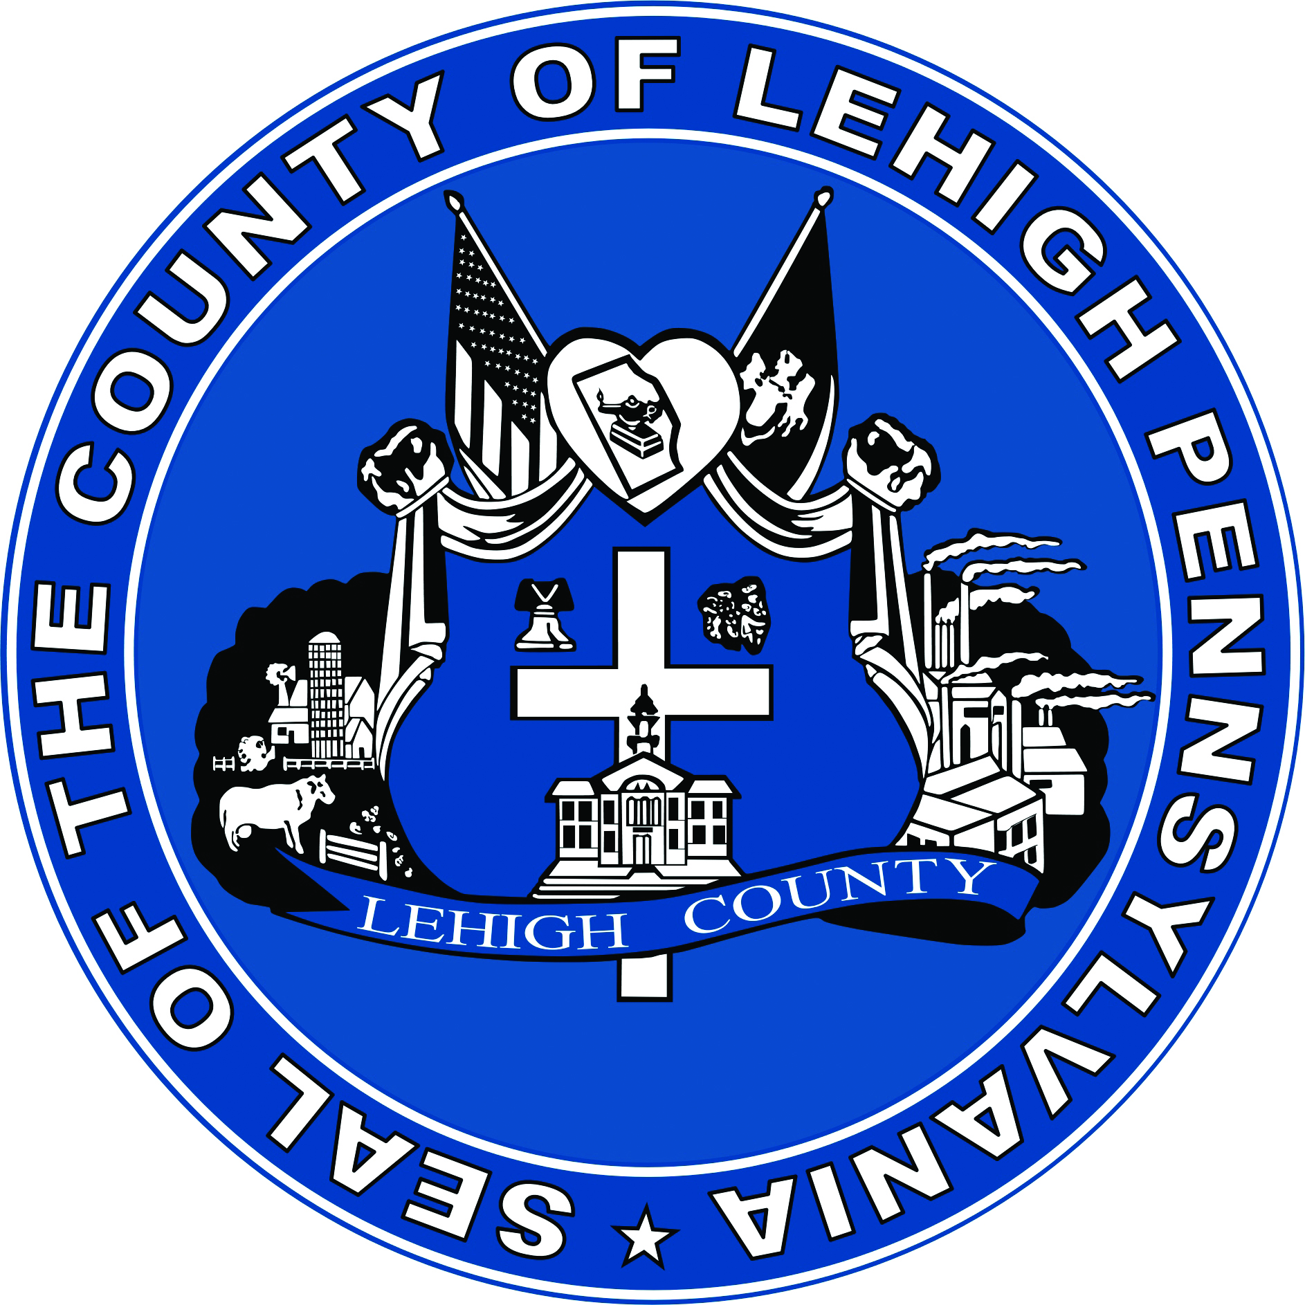LEHIGH COUNTY
Public Information Office
Government Center | 17 South Seventh Street
Allentown, PA 18101-2401
Phone: 610-782-3001 | Fax: 610-871-2755

MEDIA ADVISORY

FOR IMMEDIATE RELEASE: CONTACT: Jill Orosky
June 6, 2023 610-782-4600

LEHIGH COUNTY OFFICIALS URGE RESIDENTS TO TAKE PRECAUTIONS

Allentown, PA – Lehigh County residents should be advised that The smoke haze and smell permeating Lehigh County and the surrounding area is due to wildfires in Quebec, Canada. The Lehigh County Emergency Management and 9-1-1Communications Center urge residents:

- Please do not call to report smoke conditions due to the wildfires in order to prevent overload on the 9-1-1 system. If residents visually observe a fire or emergency, they are urged to call 911immediately as always.

- Those prone to respiratory illness, young children and the elderly should be aware that an air quality alert has been issued by the Pennsylvania Department of Environmental Protection for Wednesday, June 7, 2023, for the Lehigh Valley-Berks Area, which includes the counties of Berks, Lehigh and Northampton.

The U.S. Environmental Protection Agency’s (EPA) Air Quality Index (AQI) provides
standardized color codes for forecasting and reporting daily air quality. Green signifies good air quality; Yellow means moderate air quality; Orange represents unhealthy pollution levels for sensitive groups of people; and Red warns of unhealthy pollution levels for all.

At the time of this release, current Lehigh County air quality is red, which indicates an unhealthy level of air pollution

An Air Quality Action Day is declared when the AQI is forecasted to be Code Orange or higher. On an Air Quality Action Day, young children, the elderly, and those with respiratory problems, such as asthma, emphysema, and bronchitis, are especially vulnerable to the effects of air pollution and should limit outdoor activities. …(MORE)

Page 2

Residents and businesses within Air Quality Action Day areas are strongly encouraged to voluntarily help reduce fine particulate matter air pollution by:

- Avoiding the open burning of leaves, trash, and other materials; and
- Avoiding the use of gas-powered lawn and garden equipment.

For more information, visit DEP at www.ahs.dep.pa.gov/AQPartnersWeb , EPA’s AirNow at www.airnow.gov , or Air Quality Partnership of Lehigh Valley-Berks at
www.airqualityaction.org .

For more information, please call the Lehigh County Emergency Management Agency at (610) 782-4600.
###

