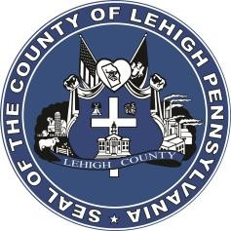

LEHIGH COUNTY

Public Information Office

Government Center

|
17
South
Seventh Street

Allentown, PA

18101
-
2401

Phone:
610
-
782
-
300
2

|
Fax: 610
-
8
71
-
275
5

Press Release

FOR IMMEDIATE RELEASE: CONTACT: Adrianna Calderon
December 20, 2023 610-782-3002

Lehigh County Courthouse Closure Update

LEHIGH COUNTY, PA- P.F.A. Hearings scheduled for Thursday, December 21st will be held in Courtroom 1B of the Historic Lehigh County Courthouse.
The main Lehigh County Courthouse will be closed on Thursday, December 21st due to a major power outage. Other than the PFA Hearings, all other court proceedings for December 21st in the main Lehigh County Courthouse will be rescheduled by the Court.

Additional information will be provided as it becomes available on the Lehigh County webpage. (https://lehighcounty.org/)

###

