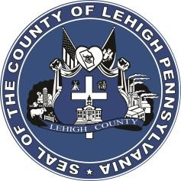

LEHIGH COUNTY

Public Information Office

Government Center

|
17
South
Seventh Street

Allentown, PA

18101
-
2401

Phone:
610
-
782
-
300
2

|
Fax: 610
-
8
71
-
275
5

Press Release

FOR IMMEDIATE RELEASE: CONTACT: Adrianna Calderon
September 6th, 2023 610-782-3002

Lehigh County Postpones Household Hazardous Waste Event

LEHIGH COUNTY, PA- Lehigh County’s Household Hazardous Waste event, originally scheduled for September 16th, 2023, is being postponed until further notice.

The event will be rescheduled and event details will be shared as soon as they are confirmed.

XXX

